Page 103, ***Java Programming A Comprehensive Introduction***

Explain the execution of the following Nested **while** loops

for (int a =0; a <3; a++){

System.out.println("Outer loop count: " + a);

System.out.print(" Inner loop count: ");

int t = 0;

while(t<100){

if(t == 10) break;

System.out.print(t + " ");

t++; }

System.out.println();

}

System.out.println("Loops complete");

**First It would loop the 1st time of outerloop, and go to the inner loop and print 1 to 9**

**Then It would loop the 2nd times of outerloop, and go to the inner loop and print 1 to 9**

**Next it would loop the 3rd times of counter loop, and go to the inner loop and print 1 to 9**

**At the last, it would print loops complete.**

**Programming Assignments**

Page 116 #20, ***Java Programming A Comprehensive Introduction***

**Task 1:** Print the following combination of stars using a **for** loop nested inside a **for** loop. Then a **while** loop nested inside a **for** loop.

Each letter will have two separate programs that produce the same output.

Attach Snipping photo of the source code for all 6 exercises and output.

A.

*****

****

***

**

*

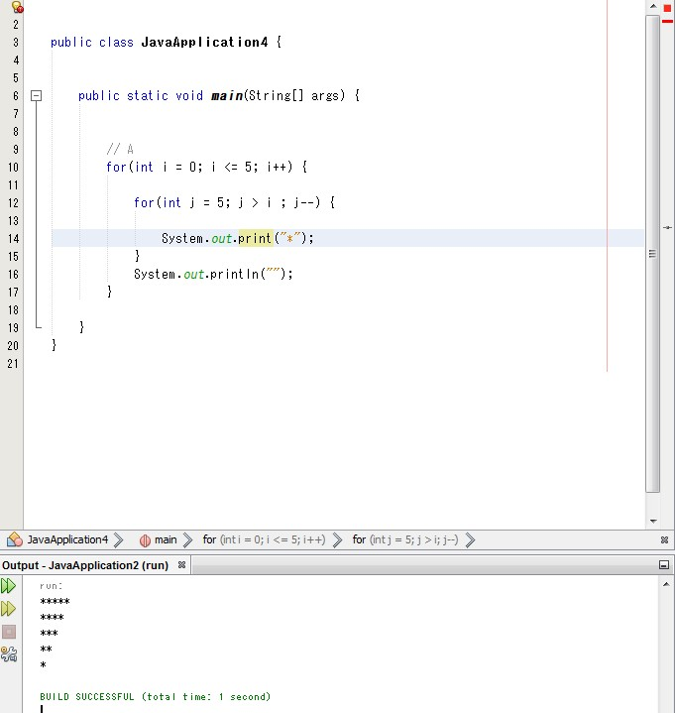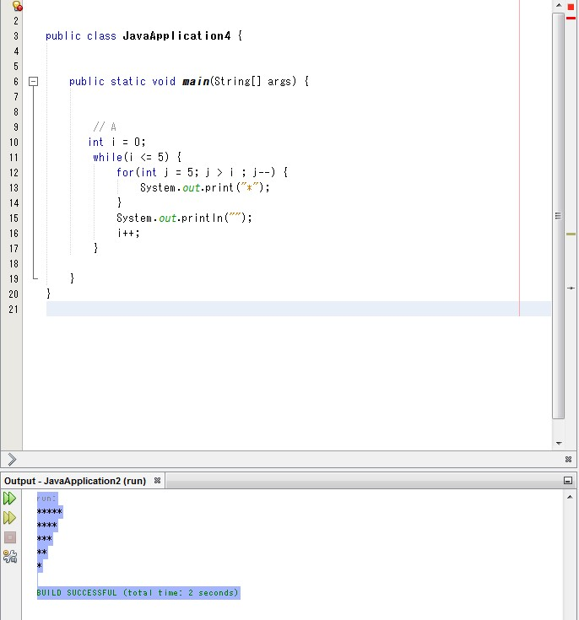

B.

*

**

***

****

*****

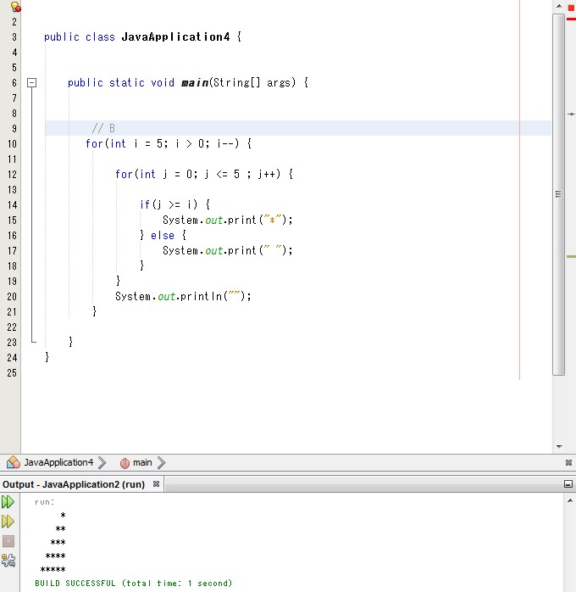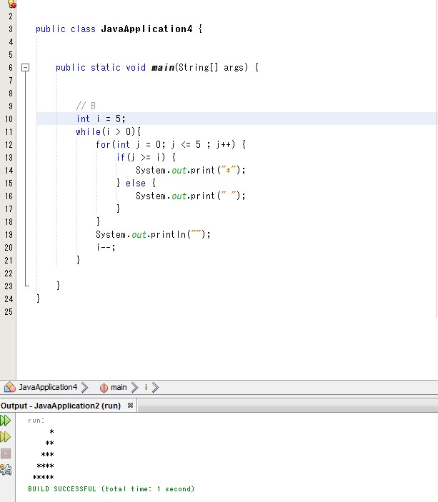

C.

**********

********

******

****

**

